East Knox 25/26 Fourth Grade Supply List
Backpack (no wheels please) | 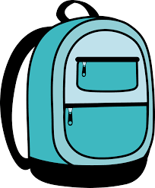 | 1 pair of Headphones or earbuds | 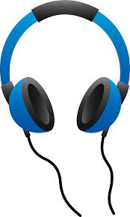
Scissors | 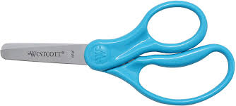 | 2 packs of Loose-leaf notebook paper  Wide Ruled | 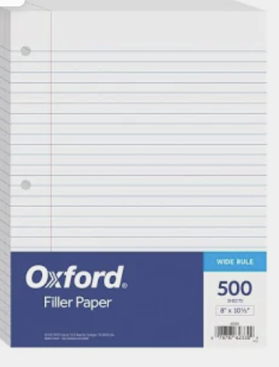
1 - Water Bottle | 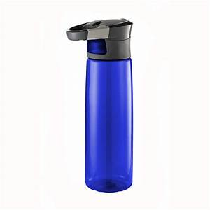 | 4 packs of Plain No.2 Pencils (preferably sharpened) | 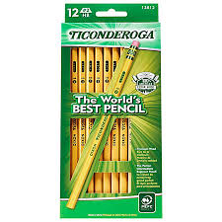
2 Packages of lined white notebook cards | 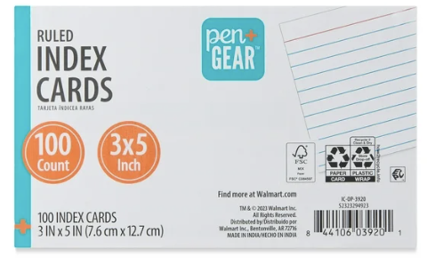 | 2 Packs of sticky notes | 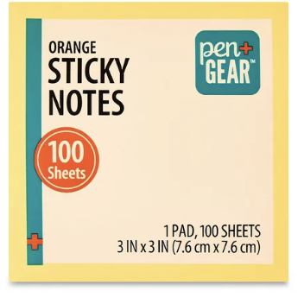
2 packs Dry-Erase Markers | 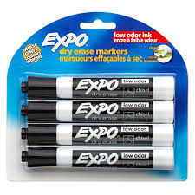 | 4 Glue Sticks | 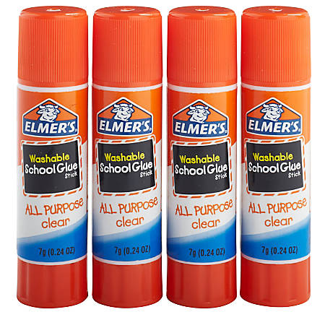
2 packs of Pencil Cap Erasers | 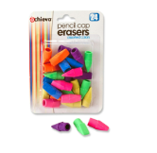 | 1 Multi-color pack of highlighters | 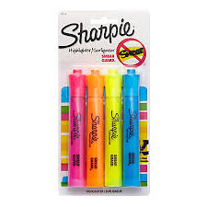
1 Box of Colored Pencils (Student Preference) | 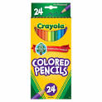
Silva and Jones  Specific  - 1 box of Crayons  - 3 pocketed folders with brads | 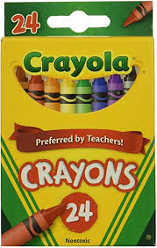  Folders: Blue, black, yellow (One of each) | Coffey and Greenway Specific  - 1 set of fine line markers  - 5 pocketed folders with brads | 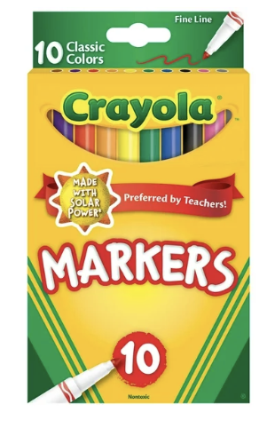  Folders: Blue, green, red, purple yellow (One of each)
Wish List: | Donations of headphones as they are often broken throughout the year | Wish List: | Hand Sanitizer, Facial Tissue, Baby wipes, Gallon/sandwich bags, paper towels

